Stellar Structure: Introductory Assignment
Ian Fare – 001413393
Jan. 16, 2017

Question 1

- The first paper that Dr. Sills published is:
Are Blue Stragglers Mixed during Collisions?
Sills, A.P., Bailyn, C.D. and Demarque, P., 1995. Are Blue Stragglers Mixed during Collisions?. The Astrophysical Journal Letters, 455(2), p.L163.
http://adsabs.harvard.edu/abs/1995ApJ...455L.163P
- Dr. Parker’s most cited paper (the Dr. Laura Parker at McMaster) is (cited by 246 according to the ADS Abstract Service, or 313 according to Google Scholar):
First Cosmic Shear Results from the Canada-France-Hawaii Telescope Wide Synoptic Legacy Survey
Hoekstra, H., Mellier, Y., Van Waerbeke, L., Semboloni, E., Fu, L., Hudson, M.J., Parker, L.C., Tereno, I. and Benabed, K., 2006. First Cosmic Shear Results from the Canada-France-Hawaii Telescope Wide Synoptic Legacy SurveyBased on observations obtained with MegaPrime equipped with MegaCam, a joint project of CFHT and CEA/DAPNIA, at the Canada-France-Hawaii Telescope (CFHT), which is operated by the National Research Council (NRC) of Canada, the Institut National des Science de l’Univers of the Centre National de la Recherche Scientifique (CNRS) of France, and the University of Hawaii. This work is based in part on data products .... The Astrophysical Journal, 647(1), p.116.
http://adsabs.harvard.edu/abs/2006ApJ...647..116H
- Dr. Wadsley has published 123 papers, of which 102 are refereed.
- Many of Dr. Wilson’s papers are about the interstellar medium (ISM), and molecular gas in nearby galaxies.
- Honestly I’m not quite sure what the first paper published by an astronomer at McMaster is. I’ve gotten as far as this search: http://adsabs.harvard.edu/cgi-bin/nph-list_connect?aff_list=*mcmaster*&db_key=AST&aff_list_ln=YES&version=1
I find that the oldest article from McMaster in the ADS abstracts is “REVIEW ARTICLES: Mass spectrometry” by H.G. Thode. He was not an astronomer, though, and that is not an astronomy paper. The astronomy database includes many geochemistry papers.
In 1968, there is a mention of stars: “Relative Proton Number in Neutron Star Matter” (http://adsabs.harvard.edu/abs/1968PhRv..176.1496N)
In April of 1976, H.G. Thode published an article on lunar rocks, and the Moon is indeed in space but Dr. Thode was still not an astronomer, and it is still a geochemistry paper. (http://adsabs.harvard.edu/abs/1976LPSC....7..459T)
For a number of years after that, there were papers that make me wonder exactly what threshold one must cross to become an astronomer. There are a few papers on tensor analysis of black holes, but it looks like they’re primarily math papers written by mathematicians...
There are other papers on astronomical topics (http://adsabs.harvard.edu/abs/1977GReGr...8..877I), but I’m still not exactly sure what is astronomy, versus physics or math.
Finally, there are papers in 1978, “Short-term time variability of Cygnus X-1. II” and “On the physical reality of the millisecond bursts in Cygnus X-1 - Bursts and shot noise”, which I think are unambiguously observational astronomy. (http://adsabs.harvard.edu/abs/1978ApJ...219.1029S; http://adsabs.harvard.edu/abs/1978ApJ...221..228W).
Question 2

I chose the paper “Simplified derivation of the collision probability of two objects in independent Keplerian orbits” (JeongAhn and Malhotra, 2017) https://arxiv.org/abs/1701.03096. It was submitted to The Astrophysical Journal on January 11, 2017, but I think not yet accepted. It describes a method of determining the probability of two objects in Keplerian orbits colliding. Öpik (1951) and Wetherill (1967) created a popular method of doing so, and JeongAhn and Malhotra claim to have re-derived it in a simpler and more physically motivated way. This paper also addresses the singularity in Öpik and Wetherill’s method, which occurs with tangential encounters between two bodies. The authors accomplish normalize it by making a modification to Öpik and Wetherill’s formulae: instead of approximating the Keplerian orbits as linear at the point of intersection, JeongAhn and Malhotra approximate them as parabolic.

This paper caught my eye because it seems like a really simple calculation that might have many important applications. The authors aren’t investigating any novel phenomenon, but rather improving how well we can predict a simple one. They’ve improved, and re-derived in a useful way, tools (i.e. methods of finding the probability of the collision of two bodies) that can be used in many different applications, from estimating the risk of collision of near-Earth asteroids to characterizing planet formation.

Question 3

I have included the “paper” as “assignment_1_LaTeX.pdf”.

Question 4

I am including results of my Runge-Kutta numerical solution with the constants A=1.0, b=1.0, and c=5.0.

A really bad h value is h=0.25:
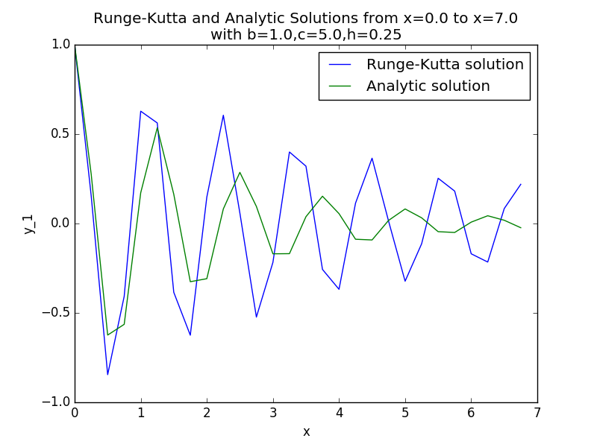

A “pretty good” h value is h=0.1:
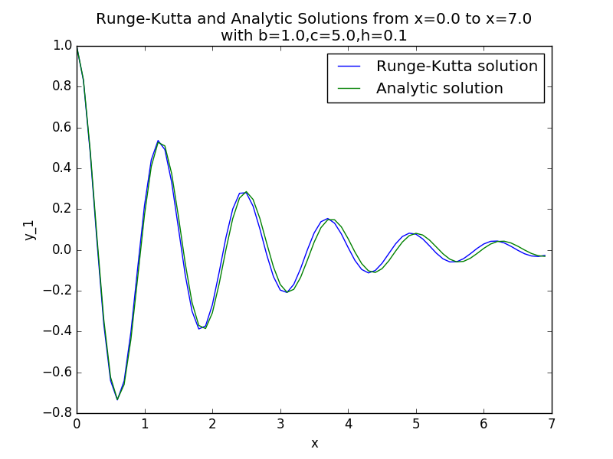

The best h-value I got is h=0.001:
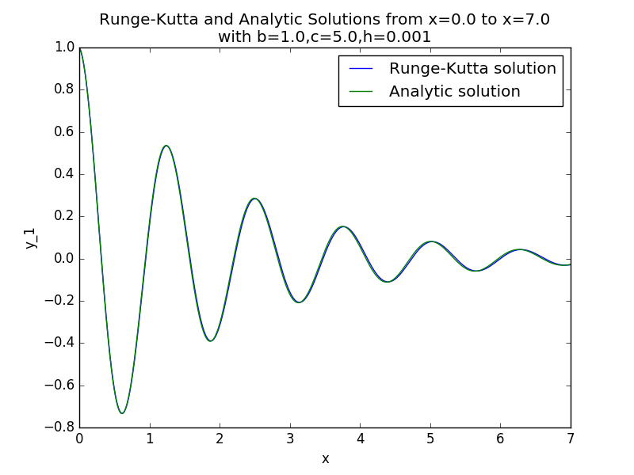

Actually, using any h values smaller than h=0.001 gives me about the same thing as h=0.001; they might be invisibly better or worse but they’re pretty indistinguishable. So really, my best h value is anything lesser than or equal to 0.001.

I should also note that my Runge-Kutta numerical solution does not work well when b is large relative to c. It is more accurate when the rate of decay is slow, and it has the chance to plot many periods of the oscillator. However, it does not do well, even with small h values, when the oscillator decays very quickly. For example, when b=3.0 and c=2.0:
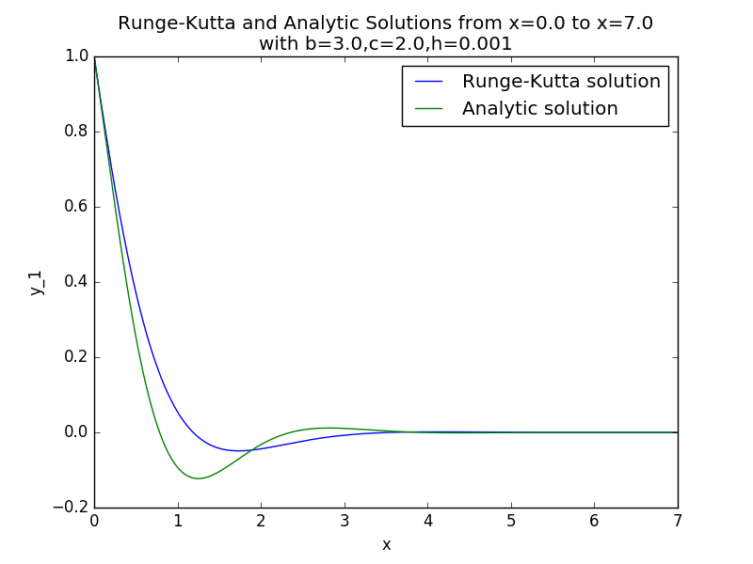

I’m still not confident that this is just a feature of the Runge-Kutta approximation and not an error in my implementation – but after a few hours of scrutinizing my code, I still didn’t find any errors, so I guess I’ll find out soon enough if anything was wrong.

